CS6880: Systems Engineering for Deep Learning

Submitted by: Sooryakiran (ME17B174)

Part A1
The Pytorch implimentations of the following architectures given in the MLPerf document have been obtained and a sample input output pair is also given.

Model | Task | Dataset | Source | Sample Output
Resnet50-v1.5 | Image Classification | Imagenet | Link | Input:  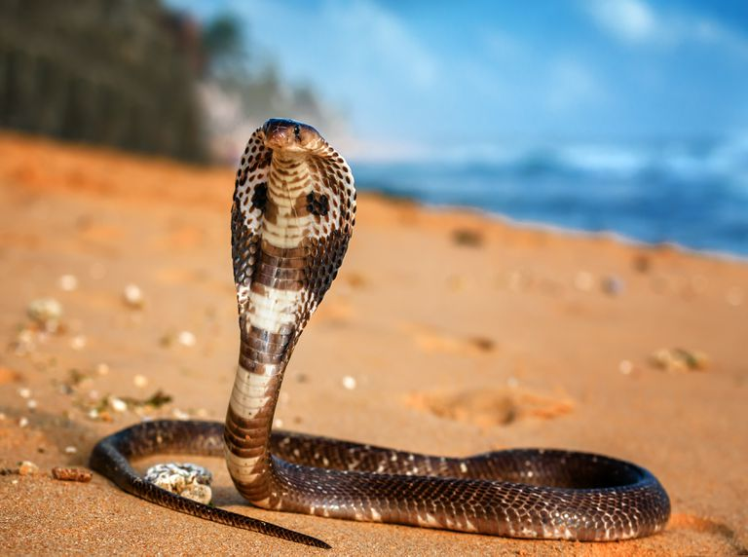  Output:  Indian cobra, Naja naja 99.97%  water snake 0.011%  night snake, Hypsiglena torquata 0.0080%  hognose snake, puff adder, sand viper 0.0033%  horned viper, cerastes, sand viper, horned asp, Cerastes cornutus 0.0022%  Remarks: Correct Prediction with very high confidence.
Mobilenet-v1-224 | Image Classification | Imagenet | Model  Weights | Input:  Output:  green mamba 99.98%  ringneck snake, ring-necked snake, ring snake 0.0047%  boa constrictor, Constrictor constrictor 0.0040%  vine snake 0.0025%  green snake, grass snake 0.0016%  Remarks: Identifies it as a snake, but predicts the wrong species.
SSD-ResNet34 | Object Detection | COCO

